Project Report: Q-Learning and Deep Q-Network for Maze Pathfinding

1. Introduction
Reinforcement Learning (RL) allows an agent to learn optimal behaviors through trial and error by interacting with an environment. In this project, I experimented with two fundamental RL algorithms Q-Learning (a tabular method) and Deep Q-Network (DQN) (a function approximation method) to solve a 5x5 maze navigation problem.
The goal was to train an agent starting at coordinate [0,0] to navigate around obstacles (walls) and reach a fixed destination at [4,4] to maximize its total reward. This report gives details around the action selection strategies, algorithm designs, experimental results, and a hyperparameter analysis of the training process.

2. Problem Formulation & Environment

Problem Formulation
Before designing the agents, I am formally defining the environment as a Markov Decision Process (MDP) as below:
1. State Space: The environment is a 5x5 grid. The agent's position is given by coordinates (x,y). This results in a discrete state space of 25 total states. In the Deep Q-Network implementation, these states are converted into one-hot encoded vectors and taken as input features for the neural network.
2. Action Space: At any given state, the agent has 4 possible actions: Up, Down, Left, and Right. If an action would force the agent off the grid boundaries, the agent remains in its current position.
3. Reward Structure: The reward function is critical for guiding the agent. We used the following configuration:
- Goal (+10): Reaching the coordinate [4,4]. This is a positive reward that shows the primary objective.
- Obstacle (-10): Hitting a wall. This is a large penalty to teach safety.
- Step Penalty (-1): Every movement costs -1. This penalty is essential, as without it the agent might wander endlessly in safe circles. The penalty forces the agent to find the shortest path to the goal to maximize the total return.

3. Action Selection Mechanism
Agent must balance two competing objectives to ensure the agent successfully learns the optimal path, a) Exploration (trying new things to discover potential rewards) and b) Exploitation (using known information to maximize rewards).
We implemented the $ϵ$-greedy (Epsilon-Greedy) strategy for action selection in both the QTable and QNetwork classes.

Design and Implementation
The mechanism works based with a probability value called epsilon ($ϵ$). At every time step, the agent decides which action to take (Up, Down, Left, or Right) based on the following logic:
- Exploration: With probability $ϵ$, the agent ignores its current knowledge and selects a random action from the available moves. This is important in the early stages of training to avoid the agent from getting stuck in loops or local optimum.
- Exploitation: With probability $1-ϵ$, the agent selects the action associated with the highest Q-value for the current state.
  - In Q-Learning, this involves looking up the row corresponding to the current state in the table and picking the action with the maximum value (np.argmax(self.q_table[state])).
  - In DQN, the current state is passed through the Neural Network, and the output node with the highest activation is selected.

Balancing Exploration and Exploitation
To manage the trade-off over time, we implemented an epsilon decay schedule.
- Initial State: We initialized $ϵ$ at 0.9. This means the agent acts randomly 90% of the time initially, ensuring it covers a large portion of the maze.
- Decay: After every episode, $ϵ$ is multiplied by a decay factor (0.995).
- Final State: As training progresses $ϵ$ decreases, ultimately settling near a minimum value (e.g., 0.01). This changes the agent's behavior from purely random wondering to a deterministic, optimized path follower.

4. Algorithm Design
We implemented two distinct methods for updating the agent's knowledge.

A. Q-Learning (Tabular Approach)
In the tabular method, the environment is discretized. Since the maze is 5x5, there are 25 possible states. We created a Q-table of size 25x4 (States $×$ Actions).
Update Rule:
The update follows the standard Bellman equation. When the agent takes an action $a$ in state $s$, receives reward $r$, and reaches new state $s^{'}$, the corresponding cell in the Q-table is updated as:
$$Q(s,a)←Q(s,a)+α[r+γ\underset{a^{'}}{max⁡}Q(s^{'},a^{'})-Q(s,a)]$$
- Prediction: The current value $Q(s,a)$.
- Target: The immediate reward plus the discounted maximum future reward estimate ($r+γmax⁡Q(s^{'})$).
- The difference between Target and Prediction is the Temporal Difference Error, which drives the learning.

B. Deep Q-Network (DQN)
In the DQN approach, we replaced the table with a Neural Network to approximate the Q-values. This is generally required for environments where the state space is too large for a table, we applied it to the 5x5 maze for our demonstration.
Architecture:
The network (QNetwork) is a Multilayer Perceptron (MLP) defined in PyTorch:
- Input Layer: Receives a one-hot encoded vector of size 25 (representing the agent's position).
- Hidden Layer 1: Linear transformation to 128 neurons + ReLU activation.
- Hidden Layer 2: Linear transformation to 64 neurons + ReLU activation.
- Output Layer: Linear transformation to 4 neurons (representing the Q-values for Up, Right, Down, Left).
Update Mechanism:
The Q-table updates immediately after every step, whereas the DQN uses two stability techniques:
- Replay Buffer: Experiences (state, action, reward, next_state, done) are stored in a buffer. The network learns by sampling a random batch (Batch Size = 64) from this memory. This breaks the correlation between consecutive steps, which stabilizes training.
- Target Network: We maintain two networks: the Policy Network (updates frequently) and the Target Network (updates every 10 steps). The Target Network is used to calculate the expected future Q-values ($Q_{target}$).
Loss Calculation:
The network minimizes the Mean Squared Error (MSE) between:
- Current Q: Calculated by the Policy Network.
- Expected Q: $r+γmax⁡Q_{target}(s^{'})$

Key Differences
- Storage: Q-Learning stores exact values for every state and action pair. DQN stores weights of a function that approximates these values.
- Stability: Q-Learning is generally stable for small finite states. DQN requires an Experience Replay buffer and a Target Network to not let the learning process from getting diverged.
- Input: Q-Learning uses an integer index, DQN uses a one-hot encoded vector (or raw features) as input.

5. Experimental Results
The agent was trained for 500 episodes. The progression of the training is clearly visible in the given result plot and execution logs below.

Performance Analysis
- Early Episodes (0 - 100): The agent performed poorly, with average rewards hovering around -300 to -600. This is expected as $ϵ$ was high (> 0.5), making the agent to wander randomly and hit walls (penalty -10), and take many steps to find the goal.
- Mid-Training (100 - 300): A clear upward trend is visible. As $ϵ$ decayed below 0.5, the agent began using the learned Q-values. The negative rewards decreased as the agent learned to avoid walls.
- Convergence (300 - 500): The agent converged to the optimal solution. The log output shows the reward stabilizing between +2.0 and +3.0.
  - Calculation: The shortest path in the configured maze is roughly 8 steps.
  - Reward Math: (7 steps $×$ -1 per step) + (1 Goal step $×$ +10) = +3.
  - The consistent positive rewards shows the agent found the shortest path and executed it reliably.

Result Plot
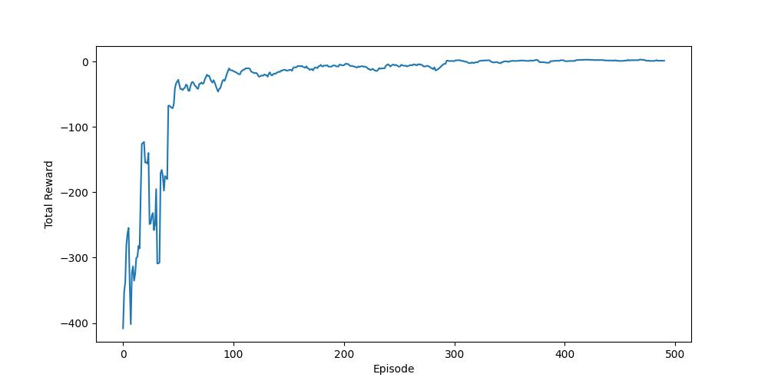
The plot shows the Total Reward on the Y-axis vs. Episode on the X-axis. The curve starts low and noisy, then exponentially rises, eventually flattening out at the maximum possible reward, showing successful learning.

6. Comparative Analysis (Q-Learning vs. DQN)

Comparative Analysis: Tabular vs. Deep RL
Since we implemented both Q-Learning and DQN for the same task, we can see distinct differences in their behavior and complexity.
1. Scalability:
- Q-Learning: Worked perfectly for this 5x5 maze because 25 states are easy to store in memory. However, if the maze were 1000x1000, the Q-table would become very large.
- DQN: The DQN shows the ability to approximate values. The memory usage of the neural network (weights) remains constant irrespective of the map size, making it the only suitable option for complex environments (like images or large grids).
2. Convergence Stability:
- Q-Learning: Converged faster and more monotonically. Since it updates specific table cells, it hardly forgets a learned path.
- DQN: Required significantly more tuning. I observed that without the Target Network and Replay Buffer, the loss would oscillate, and the agent would un-learn good behaviors. The DQN path was noisier during training compared to the constant growth of the Q-Learning agent.

7. Hyperparameter Analysis
The performance of the agent is heavily dependent on the tuning of specific hyperparameters defined in main.py.

1. Epsilon ($ϵ$) and Decay
- Setting: Initial $ϵ=0.9$, Decay = 0.995
- Impact: This high initial value was critical. In experiments where $ϵ$ started lower (e.g., 0.2), the agent often fixated on a sub optimal path (e.g., going the long way around a wall) because it didn't explore enough. The slow decay allowed sufficient time to map the entire 5x5 grid before solidifying the policy.

2. Discount Factor ($γ$)
- Setting: $γ=0.99$
- Impact: A high discount factor makes the agent far-sighted. It values the +10 reward at the end of the maze highly, even if it is many steps away. If we reduced this to 0.5, the agent might prioritize immediate safety over the long goal, potentially resulting in the agent looping in safe zones rather than rushing to the exit.

3. Learning Rate ($α$)
- Setting: $1e^{-4}$ (for DQN).
- Impact: This determined how drastically the neural network weights changed after each batch.
  - With a larger rate (e.g., 0.1), the training loss oscillated rapidly, and the agent forgot good paths.
  - With the chosen $1e^{-4}$, the learning curve was smooth, although slightly slower, which ensured stability.

4. Replay Buffer & Batch Size
- Setting: Capacity = 1000, Batch Size = 64.
- Impact: Using a batch size of 64 meant the network learned from a diverse set of 64 past moments at once. This prevented sudden forgetting, where learning a new path makes the agent instantly forget the old path.

Conclusion

The combination of a high discount factor, slow epsilon decay, and a conservative learning rate provided the most stable convergence for the given maze environment. The DQN successfully approximated the tabular Q-values, proving the reliability of neural networks for state-based pathfinding.

